Report No: ACS12445
.
Lao People's Democratic Republic
Strengthening Water Supply, Sanitation and Hygiene Sector Coordination in Lao PDR
Supporting Sector Reform for Scaling Up Rural Sanitation – Synthesis Report
.
22 May 2015
.
GWASE
EAST ASIA AND PACIFIC
.

.
.
Standard Disclaimer:
.
This volume is a product of the staff of the International Bank for Reconstruction and Development/ The World Bank. The findings, interpretations, and conclusions expressed in this paper do not necessarily reflect the views of the Executive Directors of The World Bank or the governments they represent. The World Bank does not guarantee the accuracy of the data included in this work. The boundaries, colors, denominations, and other information shown on any map in this work do not imply any judgment on the part of The World Bank concerning the legal status of any territory or the endorsement or acceptance of such boundaries.
.
Copyright Statement:
.

Table of Contents

Abbreviations 3
Acknowledgements 4
Executive Summary 5
1 Introduction 9
2 Background 9
2.1 WASH Sector Context 9
2.2 Rationale for the TA 10
3 Overview of the TA 13
3.1 Increasing Government Capacity for Planning, Coordination, Advocacy and Monitoring 16
3.2 Policy Dissemination 16
3.3 Improving Government and Partner Programmatic Approaches 17
4 Achievements against Intermediate Outcomes 17
4.1 Government Capacity increased to Plan, Coordinate, Advocate and Monitor the Rural Sanitation Component under the National Plan of Action 2015 17
4.2 Government Policy for Rural Sanitation Implementation and Financing are Widely Disseminated and Known in the Country 22
4.3 Government and Partner Programmatic Approaches for Sanitation are Improved Based on New Evidence on Results and Impacts 23
5 Summary and Way Forward 24
References 27
Annex: List of Deliverables from the TA 28
Piloting CLTS in Southern Lao PDR: 37
Lessons and Prospects 37
Introduction 37
Applicability of CLTS 37
Use of CLTS tools and techniques 37
Post-triggering follow-up 37
Government support 38
Community leadership and decision making 38
Sustainability factors 39
Prospects for scaling up 39
Summary of lessons learned 39

List of Figures
Figure 1. Map showing locations of key sanitation projects in Lao PDR in 2012/13]
Figure 2. World Bank’s Water and Sanitation Program’s country theory of change
Figure 3. Water, health and infrastructure sector co-ordination

List of Tables
Table 1. Access to sanitation by wealth quintile, 2012 (JMP)
Table 2. Results framework for enabling environment TA

List of Boxes
Box 1. Tackling nutritional stunting in Lao PDR
Box 2. Operational Guidelines for NPA implementation
Box 3. Capacity development framework and action plan.

Abbreviations
CLTS | Community-led Total Sanitation
CDD | Community Driven Development
DHHP | Department of Hygiene and Health Promotion
ESI | Economics of Sanitation Initiative
MOH | Ministry of Health
MHV | Model Healthy Village
MPWT | Ministry of Public Works and Transport
NPA | National Plan of Action
ODF | Open defecation-free
OG | Operational Guidelines
PRF | Poverty Reduction Fund
TWG | Technical Working Group
WASH | Water Sanitation and Hygiene

Acknowledgements
This report is a synthesis of the Technical Assistance (TA) ‘Supporting Sector Reform for Scaling up Rural Sanitation in Lao PDR’ (P132249) carried out by the World Bank’s Water and Sanitation Program. This TA has been implemented in close collaboration and leadership of the National Center for Environmental Health and Water Supply (Nam Saat) and Department of Hygiene and Health Promotion, the Ministry of Health. The Task Team Leader for this TA is Viengsamay Vongkhamsao. The following World Bank staff have provided valuable contributions: Bounthavong Sourisak, Community Development Specialist, Viengsompasong Inthavong, Water and Sanitation Specialist, Susanna Smets, Senior Water and Sanitation Specialist, and Almud Weitz, Principal Regional Team Leader. The peer reviewers were Ajay Tandon, Senior Economist (Health) GHNDR, Helene Rex, Sr. Social Development Specialist GSURR, Sutayut Osornprasop, Human Development Specialist, GHNDR.

Executive Summary

- This report summarizes the results and lessons learned from the TA ‘Supporting Sector Reform for Scaling up Rural Sanitation in Lao PDR’ (P132249). The TA was carried out by the World Bank’s Water and Sanitation Program from July 2012 to February 2015, and is part of a larger support program to assist the Government of Lao PDR, particularly the Ministry of Health, to scale up access to, and the use of, improved sanitation in rural areas of the country. Two other technical assistance and an impact evaluation are complementary efforts that focus on supporting demand creation for sanitation through Community-led Total Sanitation (CLTS), sanitation marketing and impact evaluation of rural sanitation in Lao PDR. The annexes to this synthesis report are the products that have been delivered to the Ministry of Health during the implementation of this TA. Further lessons learned from the broader scaling-up technical support program will be documented and disseminated in formal knowledge products. This synthesis report also provides recommendations to consolidate and accelerate the scaling up rural sanitation initiative in terms of priorities for World Bank engagement as well as direction for the Government of Lao PDR.

- The suite of TAs was developed in response to three challenges in the sanitation sector in Lao PDR:
- The sanitation access agenda was far from being finished. Data from the WHO/UNICEF Joint Monitoring Programme showed that by 2014, Lao PDR had met the MDG target of 65% access to improved sanitation. However, that still left almost half the population (42%) without access and in rural areas, where the majority of the poor live, access remained well below the MDG target. Moreover, while 99% of the households belonging to the richest quintile had access, the figure was only 13% for the poorest quintile.
- Sanitation had a low profile on the government agenda. The National Center for Environmental Health and Water Supply (Nam Saat) had a low profile within the Ministry of Health (MOH) and budgetary allocations for rural sanitation were low. Sector staff capacity was highly constrained, both quantitatively and qualitatively, with only 7-10 staff deployed for health programs per province and none of them specifically for sanitation and hygiene, and 1.4 health staff at district level serving an average 61 villages. Sector coordination and information sharing between government and development partners was weak.
- Poor sanitation was impacting on health and economic development of the country. Poor sanitation and hygiene caused at least three million disease episodes and 6.000 premature deaths annually while stunting rates among children in rural areas were very high at 49% in 2011. National economic losses due to poor sanitation totaled USD 193 million per year, equivalent to 5.6% of GDP (Hutton et al, 2009).

- The development objective of the TA was to increase the capacity of the Government of Lao PDR to effectively lead, coordinate, build the capacity of implementers and monitor for accelerating sustainable and equitable access to rural sanitation services for the poor at scale. The TA focused on three intermediate outcomes, with progress against each as follows:

- Government capacity increased to plan, coordinate, advocate and monitor the rural sanitation component under the National Plan of Action 2015.

- Sector co-ordination has improved. World Bank support included exposure visits to Cambodia for senior government officials and drafting Terms of Reference for the WASH Technical Working Group, which has met monthly since 2012 and has become an effective platform for co-ordination and consensus building. The Group still needs to take on a more strategic role in sector planning and decision making, however, and the prospects for this are improving with the introduction of Joint Annual Sector Reviews, the first of which is due to take place in May 2015. Co-ordination also needs to be improved at provincial level, since responsibility for WASH budgeting and operational planning rests with this tier of government.

A national capacity building framework has been established. The TA facilitated the formulation of a capacity development framework for scaling up rural sanitation, based on a national needs assessment, and this culminated in the adoption in August 2014 of an Action Plan for implementation of the framework at national, provincial and local level. Implementation has begun in Champasak and Sekong provinces with World Bank support, but additional funding is needed to roll out the plan nationwide.
- Sector monitoring is still being developed. Efforts to strengthen sector monitoring began recently. The TA supported government in the piloting of a dedicated rural sanitation monitoring system in Champasak and Sekong provinces, with the intention to use this as the model for a national framework. A study tour to Indonesia provided government partners with both an appreciation of the need for improved monitoring and a vision of what an effective and affordable system using low-cost technologies would look like.

Sector advocacy has improved based on new evidence. This has been a substantial part of the TA and included dissemination of relevant research and advocacy materials such as a Research Brief on sanitation and stunting; Operational Guidelines for implementation of the National Plan of Actions on Rural Water Supply, Sanitation and Hygiene (RWSSH); and videos on scaling up sanitation. The TA also supported government participation in and contribution to regional WASH fora including East Asia Sanitation Conferences in Manila and Bali and international meetings such as the High Level Meetings of the Sanitation and Water for All initiative in Washington DC.

- Government policy for rural sanitation implementation and financing are widely disseminated and known in the country.

- Joint strategy and operational guidelines have been developed. In addition to a revised National Plan of Action (NPA) for Rural Water Supply, Sanitation and Hygiene incorporating measures for scaling up sanitation and hygiene promotion, the TA helped to develop Operational Guidelines jointly agreed with 3 key development partners to support NPA implementation and adopted by the Department of Hygiene and Health Promotion (DHHP) in 2013. The Guidelines were needed to help address the fragmented nature of sector support and the lack of a common operational approach amongst external support agencies. However, Government has not yet identified the human and financial resources needed for implementation of the NPA, and the Guidelines have yet to be widely disseminated to the provinces. Further constraints are the limited time horizon of the NPA (it expires in 2015) and the absence of a national WASH sub-program under the Ministry of Health. The Minister of Health does, however, recognize the need for a policy to underpin a future program, and has requested assistance in policy development during 2015.
- Sanitation financing has not progressed. One aspect of the TA which has not progressed is the development of a sanitation financing policy, due to limited government interest in taking this forward. Having said this, a reward scheme testing different innovative incentives is now being tested in Champasak and Sekong with World Bank support and the findings should help strengthen the arguments for developing a clear financing policy in the future.

- Government and partner programmatic approaches for sanitation are improved based on new evidence on results and impacts.

- Given the limited government funding allocated to sanitation, another route to scaling up is to integrate sanitation within ongoing poverty reduction or health-related programs, not least on nutrition. Government interest in malnutrition has grown recently and it has developed a draft nutrition program (2016-20) which recognizes WASH improvements as a priority intervention. In addition the World Bank-funded Poverty Reduction Fund (PRF) now plans to engage in sanitation and hygiene promotion following exposure visits and dialogue with WSP. Nam Saat (under DHHP) has the institutional mandate for rural sanitation, but this partnering with PRF will enable it to draw on the human resources available in PRF, which has a strong presence at community and kumban (village cluster) level.

Recommendations and Way Forward
- Based on the TA results and lessons, a set of key recommendations has been developed both for future World Bank engagement in and support to the sector as well as for action by the Government of Lao PDR at policy level.
World Bank Engagement:
- Sector policy development. Following the government’s bold commitments at the High Level Meeting on Sanitation and Water for All in 2014 and the national target on access to clean water and improved sanitation at 90% and 80% respectively by 2020 (the Five-Year National Social-Economic Development Plan 2016-2020), the Ministry of Health had requested UNICEF and the World Bank to assist in developing an overarching policy and strategy for both urban and rural water supply, sanitation and hygiene, providing a strong basis for continuation of support to the government efforts in the policy and strategy development area.

- Institutionalization of capacity building for rural sanitation. Following the adoption of the national capacity building framework, funding will be needed to implement the Government’s commitment on strengthening the capacity to deliver WASH services. Several development partners and NGOs have expressed interest in supporting the framework that was developed through this TA, including the Global Sanitation Fund administered by the Water Supply and Sanitation Collaborative Council which is expected to start its program for Lao PDR towards the end of 2015. Continued technical engagement by the World Bank in this area is proposed in order to bring in pioneering experience and global lessons/best practice on institutionalizing capacity building for rural sanitation.

- Scaling-up rural sanitation service delivery through PRF and nutrition programs. As it will take time for the Government to put in place the required human resources and capacities at provincial and especially at district level and below, innovative solutions are needed to address the service delivery gap. Developing such solutions through leveraging other government programs, such as PRF as well as the multi-sectoral nutrition program are promising not only for Lao PDR but equally in other Asian countries. Integrating sanitation and hygiene and equipping PRF staff and facilitators with the right tools and capacities to support behavior change can potentially play a transformative role for delivering sanitation promotion services at scale. Similarly, within nutrition programs, community-based interventions on sanitation can be included. Moreover, sanitation behavior change messages can be strengthened through inclusion in integrated outreach services and social and behavior change campaigns delivered through the health system.

Policy Recommendations for the Government:
- Development of a national rural sanitation program. Advocacy is still needed so that tested approaches are adopted widely and provincial programs receive the funding they need to go to scale. It appears that external funding for sanitation is increasing, partly via the nutrition program, but in the absence of a national rural sanitation program, MOH is not yet pro-actively coordinating the deployment of these funds and sub-sector activity remains somewhat disjointed. Rather than being a sparsely funded activity under MOH’s national program on Health and Hygiene Promotion, a sub-program on rural water supply, sanitation and hygiene would be more suitable, including the development of a harmonized financing guideline, especially in the context of the existing access inequalities among rural populations.

- Development of a results monitoring system and planning at national and especially sub-national levels. Another outstanding challenge is to improve sector coordination and monitoring at provincial level and down to district level, especially in the context of multi-sectoral nutrition interventions including WASH. While May 2015 will see its first official joint annual review for Water, Sanitation and Hygiene jointly conducted for urban and rural sectors, reliable and timely monitoring data at national scale for rural sanitation is lagging. As the Government will scale up sanitation promotion to more districts and provinces with the help of development partners, monitoring and verification of data will become of crucial importance to ensure effective targeting and service delivery. While pilots introducing sanitation monitoring systems are advancing, lessons on how key information is best collected from the districts to inform planning and decision making at provincial level will become available that can inform the development of a nation-wide system.

1 Introduction
- This note summarizes the Technical Assistance (TA) ‘Supporting Sector Reform for Scaling up Rural Sanitation in Lao PDR’ (P132249) carried out by the World Bank’s Water and Sanitation Program from July 2012 to February 2015. It documents the results and lessons learned and makes recommendations on next steps to consolidate and accelerate the scaling up initiative.

- This TA is part of a larger support program to assist the Government of Lao PDR, particularly the Ministry of Health, to scale up access to, and the use of, improved sanitation in rural areas of the country. Technical Assistance P132453, P132368 and P151311 are complementary efforts that focus respectively on supporting demand creation for sanitation through Community-Led Total Sanitation, Sanitation Marketing and Impact Evaluation of Rural Sanitation in Lao PDR.

2 Background
- Lao PDR is an ethnically diverse country, comprising 49 ethnic groups with a corresponding number of different languages, cultures and traditions. Almost half of its population of about 6.2 million (2010) are ethnic people scattered in the upland areas. Some 70% of the population is rural, 17% reside in larger urban centers and the remaining 13% live in small towns. Annual population growth rates in small towns are reported to be 4-5 percent compared to the national average of 2.5 percent. The country is divided into northern, central and southern regions, consisting of Vientiane Capital, 16 provinces, 143 districts and more than 11,000 villages.

- Lao PDR is classified as a lower middle-income country and is one of the poorest countries in East Asia. Poverty is largely a rural phenomenon: 84% of the country’s poor are rural inhabitants, and depth and severity of poverty are much higher in rural areas. Almost 2 million rural inhabitants fall below the poverty line, and many of these are unable to meet even their basic food needs (Robinson, 2009). The country was ranked 139 out of 187 countries the 2013 Human Development Index, in spite of rising slowly over the preceding decade (UNDP, 2014). Agriculture is the largest sector of the economy. In 2005, about 73 percent of population lives in rural areas. Since 1995 there has been a substantial movement from rural to urban areas across all provinces. In 1995, 83 percent of the population lived in rural areas (Population Census, 2005).

- Lao PDR is a highly aid-dependent country, with one of the highest per capita levels of aid in the world. Capital investment in Lao PDR is financed almost entirely by foreign sources, predominantly official development assistance (Giltner et al., 2010).

2.1 WASH Sector Context
- Institutional responsibilities for water supply and sanitation sector lie with the Ministry of Public Works and Transport (MPWT) and the Ministry of Health (MOH): the former is responsible for urban water supply with most of the operational responsibilities delegated to the Department of Housing and Urban Planning, while the latter is responsible for rural (non-piped) water supply and for sanitation promotion throughout the country. However, urban and rural definitions and mandates for sanitation are not well defined. Technical and promotional responsibilities within MOH are delegated to the National Centre for Environmental Health and Water Supply (Nam Saat Central).

- Prior to the scaling up rural sanitation program there had been a number of government and donor-assisted projects promoting latrine use and basic hygiene in rural areas, but they tended to promote relatively expensive toilet designs, relying heavily on the provision of subsidies towards hardware costs. These projects largely failed to stimulate real demand for toilets and had a limited impact on the level of latrine use nationally. There had been a steady increase in rural latrine use in recent years, but this had resulted mostly from households making their own investments in toilet facilities, not from the efforts of government or development partners (Giltner et al., 2010). All of the above suggested the need for a new approach to sanitation promotion if the use of improved sanitation was to be expanded and accelerated nationwide.

2.2 Rationale for the TA
- This TA built upon the World Bank’s earlier country engagement which included two pillars: Advocacy and Policy, and Institutional Capacity Building with a focus on the nodal ministries of Health (for the rural sub-sector) and Public Works and Transport (for urban). The first pillar focused on supporting the government in the development of the Rural Water Supply, Sanitation and Hygiene Strategy, which was eventually issued in 2012 as the National Action Plan for Rural Water Supply, Sanitation and Hygiene; and development of an evidence base for use in advocacy. Activities here included research under the Economics of Sanitation Initiative, sanitation and stunting analysis and a sanitation financing study. This support also enabled government to participate in high level regional meetings on sanitation aimed raising the profile of the sanitation agenda. The second pillar addressed issues at operational level and included, amongst other things, orientation for government and development partners on successful innovative approaches developed in the region and beyond. This again included the participation of government clients in regional learning events, plus small-scale piloting of Community-Led Total Sanitation (CLTS), establishment of a pool of CLTS resource persons at national level and preliminary work on the development of a CLTS training material.

- The CLTS pilot began in 2009 in Champasak and Sekong Provinces and was led by Nam Saat. This proved to be successful, with all six targeted villages declared open defecation-free (ODF) by July 2010. Inspired by the pilot, provincial authorities became keen to expand to additional villages and districts in the two provinces. A number of other development agencies also introduced CLTS within their county programs, in collaboration with Nam Saat, and its use in Lao PDR has expanded significantly since then (see figure 1).

Figure 1. Map showing locations of key sanitation projects in Lao PDR as at 2012/13
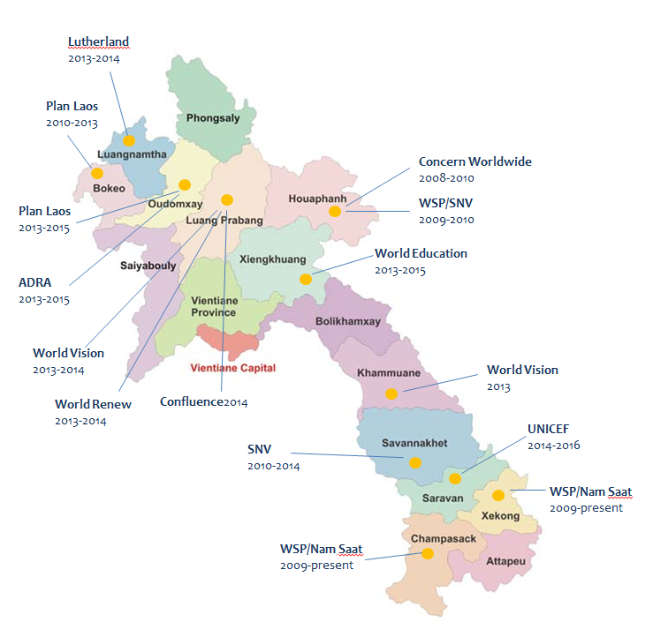

- To complement the CLTS initiative, and based on the evidence of the financing study that it was mostly better-off households that were installing (high end) toilets at their own expense, in early 2011 World Bank began working on product design to support the development and marketing of affordable sanitation options, in the same provinces. The World Bank also fostered regional exchanges and learning via study trips, for example to Cambodia and Indonesia to learn more about sanitation marketing, CLTS and other components of a scaling-up strategy. The scaling up program, consisting of three complementary TAs, built upon the groundwork undertaken by these earlier initiatives. It drew upon the World Bank’s Water and Sanitation Program’s global theory of change on rural sanitation and global lessons gathered through the World Bank assistance to rural sanitation in multiple countries (Perez et al, 2011).

- The TA was developed in response to four critical challenges in the sanitation sub-sector:

- Poor sanitation was impacting on health and economic development. Lao PDR had one of the lowest rates of access to rural sanitation in South-East Asia. Poor sanitation and hygiene caused at least three million disease episodes and 6,000 premature deaths annually. Diarrheal disease was tied with pneumonia as the second largest killer of children under five and research under this TA has also confirmed an association with stunting in rural areas; see Box 1. The World Bank’s Economics of Sanitation Initiative (ESI) estimated economic losses due to poor sanitation in Lao PDR totaling USD 193 million per year, equivalent to 5.6% of Lao PDR’s GDP (Hutton et al, 2009).

Box 1. Tackling nutritional stunting in Lao PDR
In Lao PDR, 44 per cent of children under-five years of age (around 417,000) are stunted (low height for age), 27 per cent are underweight and 6 per cent are wasted (low weight for height). Since the early 1990s, stunting has declined at an average annual rate of 0.8 per cent, less than the average population growth rate.

One of the outputs of the TA was dissemination of a research brief entitled ‘Investing in the Next Generation’ which examined the incidence and causes of stunting in Lao PDR. There is a growing body of global evidence that links open defecation to poor child health through at least two mechanisms. The first and most commonly recognized is diarrhea from ingesting feces. The second, which is only recently becoming understood, is a disorder of the intestine caused by continued fecal exposure. Known as chronic environmental enteropathy, the condition prevents absorption of nutrients, even without the child getting diarrhea and appearing ill.

The research investigated whether widespread open defecation and unimproved sanitation in rural Lao PDR is associated with stunting and if so, whether this could be prevented by the use of improved sanitation facilities. It also sought to find out whether there could be association between poor sanitation in one household and stunting within a neighboring one, even if the neighbors had improved facilities. This was done by conducting regression analysis on data from the Multiple Indicator Cluster Survey (2006) and the Lao Social Indicator Survey (2012). Key lessons were that:

- Children in rural villages of Lao PDR are likely to be stunted at every age, even when only a small proportion of villagers do not use improved latrines.
- Open defecation and/or unimproved sanitation in rural villages of Lao PDR is associated with shorter children living in those villages.
- Open defecation and/or use of unimproved latrines by neighbors are associated with stunting even when the next child’s family uses improved facilities.
- Lack of improved sanitation has a permanent negative impact on a child’s health and development.

Not only do the findings highlight the importance of implementing the National Plan of Action for Rural Water Supply Sanitation and Hygiene; they also provide a strong case for incorporating open defecation-free status into the criteria to be applied under the next phase of the government’s Model Healthy Village Program, in order to tackle stunting effectively.

Source: Research Brief “Investing in the Next Generation” August 2014

- Reaching the sanitation MDG target still left about half the population without access. According to WHO/UNICEF JMP data, Lao PDR had already met the MDG target of 54% access to improved sanitation by 2011. This was encouraging, but still left some three million people (almost half the population) without access and in rural areas, where many people were poor, access remained well below the MDG target. The Lao Social Indicator Survey (2012) revealed that 51.2% of rural households with road access, and only 22.5% of rural households without road access, had access to improved sanitation facilities. While 99% of the households belonging to the richest quintile had access, the figure was only 12.7% for the poorest quintile. The same survey also showed that residents of the southern region were much less likely than others to have access (34.8% compared to 61.3% in the northern region and 67.8% in the central region). Almost 49% of rural children (27% of urban children) and 61% of the poorest children (20% of the richest children) were stunted in 2011. (MICS3 data of 2006, published in 2008).

Table 1. Access to sanitation by wealth quintile as at 2012 (JMP, 2014)

- Sanitation access was largely based on self-supply and recent rapid gains were not attributable to the promotional efforts of government or development partners. A sanitation financing study by the World Bank in 2010 confirmed that public investment in sanitation in Lao PDR has been low for many years – a huge increase would be needed if universal access was to be achieved in the medium term. Moreover, with poverty levels in rural areas standing at an average of 28.6%, it appeared that most of the recent increase related to private investments by non-poor households. More needed to be done to increase access among the rural poor, both in terms of demand generation and improvements to the local supply of affordable sanitary goods and services.

- Sanitation had a low profile on the government agenda. Nam Saat (the National Centre for Environmental Health and Water Supply) had a low profile and little influence within the Ministry of Health, and budgetary allocations to rural WASH were low. As a result there was limited capacity for sanitation promotion within government or for service delivery among the general population. Sector co-ordination and information sharing between government and development partners was weak at national and provincial level and the absence of a national monitoring system further impeded evidence-based planning and decision making.

3 Overview of the TA
- This TA formed one of three components of the World Bank support to scaling up rural sanitation in Lao PDR, and focused on strengthening the enabling environment for a sustainable, cost-effective national program. The other TA focused on behavior change communication and demand generation; and strengthening the local supply of sanitation goods and services; both had national and sub-national components. These three TA components were interlinked in the theory of change as set out in Figure 2. Learning would be captured thought the process and evidence-based lessons fed back to improve program effectiveness. The focus, scope and results of the enabling environment TA are set out in Table 2 and the three components are described in more detail thereafter.

Figure 2. Underlying Theory of Change for Lao PDR
Improve health and socio-economic conditions for poor rural households and communities
Health and Economic Indicators in Lao PDR NSEDP 2011-2016
Increase access to and use of improved sanitation facilities
Lao PDR national rural target: 60% access to rural sanitation by 2015

Increase market supply and facilitate consumer uptake of affordable, aspirational and accessible sanitation facilities for all consumer groups, including poor and remote areas
Understanding market supply and consumer demands; evidence-based development of market segmentation strategy; test and develop technology options and finance options; evidence-based learning from sanitation marketing pilot; facilitate scale-up of sanitation marketing in larger programs; institutionalize support functions for sustaining and expanding sanitation markets (P132368)

Create community demand to stop open defecation and create effective consumer demand, including poor consumers, for improved sanitation facilities
Understanding sanitation and hygiene behaviors through FOAM; development and implementation of evidence-based behavior change communications for sanitation and hygiene; developing and expanding cost-effective CLTS approach and in country-capacities for scaling-up CLTS, focused on sustaining ODF and improved hygiene behaviors; understanding if and how smart subsidies can support ODF achievement at scale (P132453)

Strengthen enabling environment towards a sustainable, cost-effective national program for scaling-up rural sanitation
Support government to implement RWSS strategy and operational plan;
Assessing enabling environment weaknesses and addressing key-bottlenecks for scale-up, such as HR development, decentralization, sector coordination, planning and M&E
Strengthen policy development and financing arrangements for rural sanitation.
Fostering knowledge sharing and learning for scaling-up successful programmatic approaches (P132249)

Table 2. Results framework for enabling environment support
Development Objective
To increase the capacities of the government of Lao PDR to effectively lead, co-ordinate, build capacity of implementers and monitor for accelerating sustainable and equitable access to rural sanitation services for the poor at scale.
Intermediate Outcomes | Indicators | Results
Government capacity increased to plan, coordinate, advocate and monitor the rural sanitation component under the National Plan of Action 2015 | - The mandate of the sub-sector WASH Technical Working Group under the Departmental Task Force TWG on Hygiene and Health Promotion is effectively used for formal coordination by 2013  - A Technical Secretariat is established and staffed under the DHHP by mid-2013 to coordinate Joint Annual Reviews for rural water and sanitation by end 2013  - Human resources framework and capacity development plan developed by 2014  - National monitoring system for rural sanitation through TA on demand creation in 2 provinces has been adopted and rolled out by mid-2014 | - Achieved. Official, government-led Technical Working Group established in 2013 and now functioning under Department of Hygiene and Health Promotion, MOH with representation from Department of Housing and Urban Planning, MPWT.  - Partially achieved. No staffed secretariat but a person in DHHP assigned as Coordinator  - Achieved. Capacity development framework and plan developed and agreed in principle with DHHP / Nam Saat in July 2013.  - Partially achieved. Monitoring framework developed and being tested in the two provinces by late 2014. National roll-out not yet done
Government policy for rural sanitation implementation and financing are widely disseminated and known in the country | - The Operational Program Guidelines on rural sanitation developed, endorsed by MoH, and disseminated to provinces and partners by end 2014  - Sanitation financing policy note developed by mid-2014 and adopted by government by end of 2014 | - Achieved. OP Guidelines developed and endorsed by MOH in April 2014. Dissemination done at national level but not yet in all provinces.  - Not Achieved. PSI undertook study on ‘Sanitation Financing Potential Partner Assessment’ in April 2014. Impact evaluation on testing effectiveness of financial incentives underway
Government and partner programmatic approaches for sanitation are improved based on new evidence on results and impacts | - Evidence-based lessons identified, documented and disseminated through learning events and knowledge products such as co-financed AAA with HD team  - Programmatic sanitation approaches integrated in at least one other large-scale operation or project by mid-2014, supported by other development partners (e.g. Early Childhood Education or other community-based nutrition programs); scale-up proposal ready by mid-2015 | - Achieved. Examples include rapid assessment of ODF sustainability; national workshop on scaling up rural sanitation; exposure visits to Cambodia and Indonesia.  - Work in Progress. Work is ongoing to integrate sanitation under the World Bank-funded Poverty Reduction Fund and the future Nutrition and Health Program

3.1 Increasing Government Capacity for Planning, Coordination, Advocacy and Monitoring
- A priority under this component was to promote and support the establishment a government-led WASH Technical Working Group (TWG). When the TA started, there was an existing WASH Technical Working Group which was active and served as a vehicle for introducing CLTS to the sector at national level. This group was informal, however; its membership was made up entirely of international development agencies and it operated outside of the government framework with no official role in sector planning or decision making. Also there was (and is) an Infrastructure Sector Working Group under the Ministry of Public Works and Transport whose remit encompasses urban water supply and sanitation but not rural sanitation and hygiene promotion.

- To support and encourage the establishment of a government-led WASH TWG, the TA organized an exposure visit for senior government officials from MOH and MPWT to Cambodia to see how their own Technical Working Group functioned (and learn about sanitation marketing); and to Indonesia to learn about WASH monitoring and evaluation systems. The World Bank also helped to finalize Terms of Reference for the Technical Working Group (see Annex 2).

- A second priority was to improve the draft national WASH strategy, which was issued by the Ministry of Health in 2012 as the National Plan of Action for Rural Water Supply, Sanitation and Hygiene (NPA). The first draft NPA contained very little on sanitation promotion, behavior change communication, strengthening supply chains for sanitation goods and services, or scaling up. The TA helped to redress this imbalance so that relevant sanitation-related provisions were included.

- A further initiative was to support government in assessing capacity building needs for scaling up sanitation promotion, from national to community level. This culminated in the adoption in 2014 of a national capacity development framework and action plan (see Box 2).

- Throughout the program the World Bank collaborated closely not only with government, primarily Nam Saat under the Department of Hygiene and Health Promotion in the Ministry of Health, but also with other international development agencies working in sanitation and hygiene promotion - particularly Plan International, SNV and UNICEF. This helped to foster a common approach to scaling up within the framework of the NPA.

3.2 Policy Dissemination
- Considerable time and effort was invested in consultation and consensus building for the development of Operational Program Guidelines to accompany the NPA.

- The guidelines were prepared as a blueprint for scaling up and amongst other things define overarching principles plus specific roles and responsibilities at each level of government. They were prepared in close collaboration with the Department of Hygiene and Health Promotion which has a high level of ownership of the document and formally endorsed it in 2013. The guidelines potentially have a very significant role to play in facilitating scaling up. Box 2.

Box 2. Operational Guidelines for Scaling up Rural Sanitation in Lao PDR
These guidelines were developed to provide a systematic framework for the planning, implementation, monitoring and evaluation of rural sanitation programs under the umbrella of the National Plan of Action. This includes the roles and responsibilities of relevant state agencies at all levels. The intention is to ensure a coordinated approach nationwide, based on common national goals and priorities.

The guidelines are founded on five guiding principles: equity to ensure that all people living in remote areas have access to improved WASH services; sustainability of services and behaviors; demand creation, behavior change and strengthening supply of sanitation goods and services; shared responsibilities between stakeholders (households, government, public sector); and learning and innovation.
The document sets out a four phase program implementation cycle based on the approaches tested and refined under the scaling up program; this deals with both demand and supply-side interventions. The cycle is pitched at macro (provincial level) and so includes the process for community level engagement but goes beyond this to encompass a range of tasks at different tiers of government. A summary of the cycle is provided in Annex 3.

3.3 Improving Government and Partner Programmatic Approaches
- There were two key activities in this area. The first was to facilitate the documentation of lessons learned on sanitation and hygiene promotion at scale, and their dissemination via learning events and knowledge products (See Annex One). The second was to enhance the sanitation and hygiene promotion content of key donor-funded programs in the sector, as a contribution to national scaling up. One of these was the World Bank-funded Poverty Reduction Fund. There has been extensive dialogue with the PRF management team on how to incorporate sanitation and hygiene promotion into their projects, and personnel from their provincial and district teams made an exposure visit to ODF villages and sanitation producers in Champasak and Sekong. PRF, the World Bank with input from Nam Saat, have developed an initial plan to test such integration approaches in 2015. More recently there has been engagement with MOH regarding the ‘Model Healthy Village’ scheme and depending on how the Model Healthy Villages scheme will be continued, discussions are ongoing with MOH on redefining the Model Healthy Village criteria to include open defecation-free status, rather than the much lower levels of access in the current criteria.

4 Achievements against Intermediate Outcomes

4.1 Government Capacity increased to Plan, Coordinate, Advocate and Monitor the Rural Sanitation Component under the National Plan of Action 2015

Sector Coordination
- Sector co-ordination has improved with the establishment of a government-led Technical Working Group. This has met monthly since 2012 and has become an effective platform for co-ordination and consensus building. Examples of improved multi-stakeholder collaboration are jointly-funded (UNICEF, SNV, Plan International and World Bank) national formative research and supply chain analysis, the development of behavior change communication (BCC) tools and development of a capacity building plan for promoting rural sanitation in Lao PDR. The TWG still needs to take on a more strategic role in sector planning and decision making, however, and the prospects for this are improving with the introduction of Joint Annual Sector Reviews, the first of which is due to take place in April/May 2015. UNICEF is supporting government in coordinating the process and the Bank will facilitate a session on scaling up rural sanitation.

- A constraint on the activities of the TWG is that it lacks a staffed secretariat or at least a full-time officer to spearhead its work beyond the monthly meetings, for example working on advocacy and resource mobilization for sanitation. Currently there is only a designated coordinator for whom this is not a full-time job.

- Coordination also needs to be improved at provincial level; so far only Champasak and Sekong Provinces have made much progress in this area. This is a critical gap as responsibility for WASH budgeting and operational planning lies at this level. The optimal structure and operational arrangements for a provincial co-ordination mechanism are yet to be developed and tested.

- Nutrition is now high on the Ministry of Health agenda and with WASH, Mother and Child Health and Nutrition co-located under the same Directorate there is real potential to better plan, coordinate and develop mutually supportive interventions, including both nutrition specific and nutrition-sensitive interventions such as WASH. Members of Nam Saat are now regular attendees of meetings of the Nutrition Technical Working Group. National learning events hosted by Nam Saat, and supported by the World Bank, have on several occasions invited representatives from the national Nutrition Centre to discuss the interrelationships and operational linkages between nutrition and WASH. In addition, this TA also contributed to strengthening the WASH integration to the Bank-funded project on Community-based Nutrition (CNP) through implementation support missions to this project.
Figure 3. Organogram of WASH-related TWGs
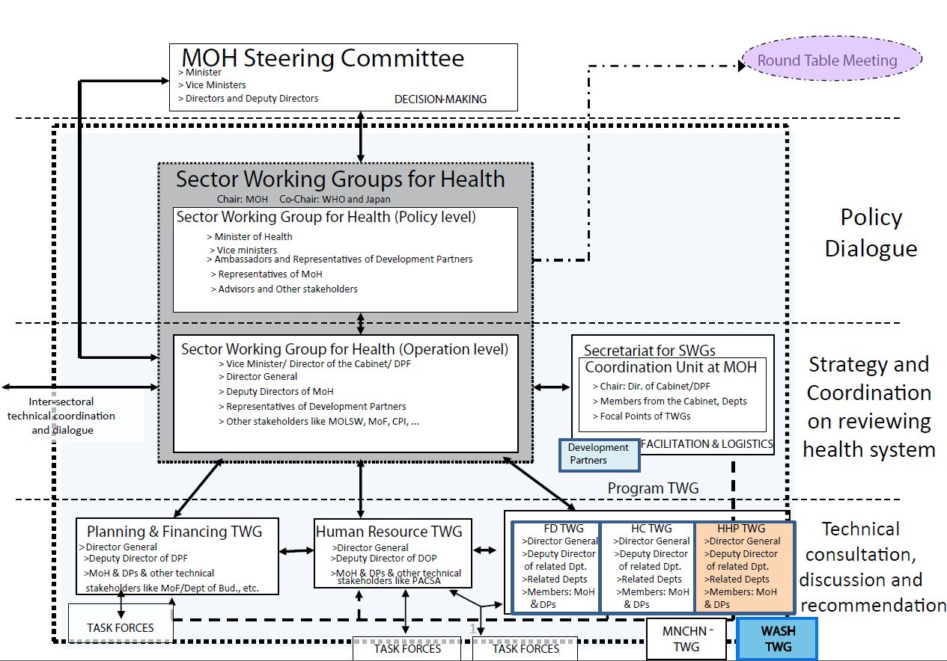

National Capacity Building Framework
- Formulation of the capacity development framework for scaling up rural sanitation, based on a national needs assessment, was followed by wide stakeholder consultation. This culminated in the adoption of an action plan for implementation of the framework at national, provincial and local level (refer to Box 3). Implementation of the plan has now begun in Champasak and Sekong provinces with World Bank support. The funds needed to roll out the plan nationwide, however, have yet to be identified.

- One specific initiative to help strengthen the expertise of Nam Saat staff is a collaboration between The World Bank and the University of Health Sciences in Vientiane capital under which CLTS and sanitation marketing modules will be incorporated into the Environmental Health Diploma course – a formal qualification for Nam Saat technical staff. The modules will use some of the training tools developed via the other TA (P132453 and P132368) supporting the national scaling up program. This should enhance expertise on sanitation promotion within Nam Saat, though limited staff numbers at district level mean that it will continue to need operational alliances with NGOs, the private sector, as well as other programs that may be leveraged due to their presence of skilled human resources at grass root level, especially PRF. Non-profit resource agencies (local NGOs Community Development and Environment Action and Lao Biodiversity Association, plus international NGOs such as Health Poverty Action and SNV) have played a vital role as resource agencies in the scaling up initiative while the NGOs iDE and PSI have led sanitation marketing research and implementation, respectively.

- A new opportunity to increase capacity for sanitation and hygiene promotion has arisen following the decision of the MOH in 2014 to revise the teaching curriculum of university students of Public Health for higher diploma and undergraduate level. Sanitation and hygiene related subjects/topics (including CLTS, Sanitation Marketing, Operational Guideline for Rural Sanitation) have been included as part of environmental hygiene major.

Box 3. Capacity Building Framework and Action Plan
A capacity building framework was developed specifically to enable nationwide adoption of the programmatic approach to sanitation and behavior change promotion as set out in the NPA Operational Guidelines. Development of the framework drew on an earlier situation analysis undertaken by The World Bank as groundwork for development of a formal WASH Diploma Course; a desk review and survey at central and provincial levels (Champasak and Sekong) in 2013; and a national consultative workshop with government and development partners in August 2014.
Up to now, capacity building in rural sanitation and hygiene promotion has typically been project-based, time and resource-intensive, disconnected from sector educational institutions and rarely sustained beyond the implementation period of projects. It has been funded by a variety of agencies, not all of which follow the 2013 Operational Guidelines. Key capacity challenges identified include the following:

1. Sector staff capacity is highly constrained, both quantitatively and qualitatively. On average there are only 7-10 staff per province for all health programs, with none deployed specifically for sanitation and hygiene. At district level, there are just 1.4 health staff per district for all health activities, serving an average of 61 villages. Some 98% of Nam Saat staff are medics or paramedics with Public Health Degrees and Diplomas and for most, their sanitation experience is based on supply-driven interventions involving subsidized toilet construction.

2. Academic training does not equip health staff for current WASH sector tasks. It contains nothing on demand creation for sanitation, supply chains or behavior change communication; neither does it address nutrition – sanitation linkages.

3. Current human resource policies and procedures are not conducive to development of the necessary capacity. Job requirements and skills are not well matched during recruitment due to quota-based systems and there is no mandatory training for staff working in rural sanitation. Sanitation has a low profile, and low funding, within the Health Ministry hence is not an attractive subject for Nam Saat staff. Similarly there is little motivation for self-development in this area since short-term in-service training offers no professional credits or basis for promotion.

4. Source materials are available for institutionalizing rural sanitation capacity building. Following the introduction of CLTS (and more recently, sanitation marketing) in Lao PDR considerable capacity building resources are now available but not, so far, incorporated into vocational and academic training programs. They include a standardized CLTS training package; a national resource pool core trainers (based at Nam Saat Central); ODF verification guidelines; a sanitation options catalogue with cost calculation guide; nationwide consumer research findings and conclusions; a country level supply chain assessment, findings and conclusions; a project unit in Nam Saat run by Center for Affordable Water and Sanitation Technology (CAWST), which has provided training on WASH technology and hygiene promotion; and project-based training from international development agencies.

Outline of the framework and action plan
The plan identifies four target groups: funding decision makers; rural sanitation program managers (provincial government staff); rural sanitation program implementers (district government staff) and implementation supporters (mass and community organizations); and private sector partners (sanitation entrepreneurs and service providers). Key elements of the action plan are outlined below and have been prepared on the assumption that Nam Saat will increase staffing so that there are 1-2 full-time staff for rural sanitation at provincial level; 1-2 full-time staff for rural sanitation at district level, supplemented by postgraduate student interns from the University of Health Sciences/Nursing College.
Target group and capacity building objectives | Proposed Action
Funding decision makers  Raise the political profile of rural sanitation and elicit budget allocations in support of NPA | - Evidence-based advocacy plan targeting policy / decision makers  - Professionally designed advocacy campaign on the case for investing in sanitation  - Involvement of influential pressure groups
Rural sanitation program managers and implementers (Provincial and district level government staff)  - Align planning and implementation of rural sanitation interventions with NPA and Operational Guidelines  - Institutionalize programmatic approaches for rural sanitation  - Enable progress and outcome monitoring for rural interventions on a national scale | Short Term Plan  - Establish Job Descriptions for managers and implementers based on the operational Guidelines  - Develop core training curricula for provincial managers and district level implementers, drawing on global sector knowledge and resources  - Introduce mandatory qualifications in sanitation and hygiene promotion  - Set up annual program of training in all provinces where donor/government funding is already available  - Establish a permanent national panel of trainers  Long Term Plan  - Update academic training for future health staff  - Offer optional rural sanitation specialization within new programs at Faculties of Social Science, Engineering and at Vocational training Schools.  - Introduce Lao-specific self-learning courses with accreditation and offer incentives for self-development within government institutions  - Attract students to the sub-sector via scholarships and internships in donor-supported project locations
Private sector partners (sanitation entrepreneurs, service providers)  1. Orient private sector on potential size of market in provinces  2. Familiarize them with appropriate technology and costed designs  3. Offer coaching and mentoring on setting up / expanding enterprises.  4. Facilitate contact between links in the supply chain, establish provider network | - Identify viable, pro-poor business models customized to meet the needs of different regions  - Develop informed choice catalogues and promotional materials suited to particular locations  - Develop a sanitation entrepreneurship training module in consultation with private sector players  - Identify small number of entrepreneurs as national trainers/coaches

Sector Monitoring
- Efforts to strengthen sector monitoring began recently. Up to now, MOH has had no proper system in place for categorizing, collecting and analyzing sanitation data and instead has relied on administrative information collected by Nam Saat district offices and reported to Provincial Health Offices. This is not always accurate and reliable, hence government has mostly relied on national surveys as measures of progress, with data reported to JMP in standardized categories. The limitation of these surveys is that they do not provide sufficient detail for every district or province to enable effective planning and targeting of interventions.

- In order to address the monitoring challenge, The World Bank is now supporting government in the piloting of a dedicated rural sanitation monitoring system in Champasak and Sekong provinces, with the intention to use this as the model for a national framework. The design and associated forms for reporting from there to Provincial Nam Saat were developed in late 2014. A national situation analysis, followed by a national monitoring and evaluation framework workshop, are planned to take place later in 2015. Lessons from the pilot-testing in the provinces are then expected to inform a future roll-out nationally.

- The study tour to Indonesia in July 2014 provided government partners with both an appreciation of the need for improved monitoring and a vision of what an effective and affordable system employing low-cost technologies would look like. The system currently being piloted draws heavily on the Indonesian example and includes benchmarking to enable performance monitoring at district level. The ODF verification guidelines issued by DHHP in 2013 (supported by TA P132453) provide an excellent basis for formulating benchmarking indicators.

Advocacy
- While no progress indicator was set for advocacy, this has been a substantial and important part of the TA. Activities included, amongst other things:
- Dissemination of relevant research and advocacy materials, some developed under this TA, others bring outputs of other World Bank initiatives. They included the Economics of Sanitation Initiative findings; National Service Delivery Assessment for urban and rural WASH, which identified critical bottlenecks in the sector; the Research Brief on sanitation and stunting; the NPA Operational Guidelines; and videos on scaling up sanitation (one completed, two more in production). The ESI has been used extensively by government partners as reference document in national level discussions on health and WASH, helping them make the case for greater attention to sanitation in resource allocation and service delivery. The sanitation video is also used regularly in national and subnational sector meetings. A well-attended dissemination seminar by both WASH and nutrition stakeholders on the sanitation-stunting research brief has contributed to a better understanding that WASH interventions no longer exclusively point to water supply improvements, but explicitly address sanitation, and especially the need for open defecation free status.
- Technical and logistical support to government participation in regional WASH fora including East Asia Sanitation Conference (EASAN) in Bali (2012), and High Level Meetings of the Sanitation and Water for All initiative. The Vice Minister for Health attended both meetings. The World Bank helped government to prepare presentation for these events, for example a presentation on the findings and implications of the Service Delivery Assessment.

4.2 Government Policy for Rural Sanitation Implementation and Financing are Widely Disseminated and Known in the Country

Policy and Operational Guidelines
- In addition to a revised National Plan of Action for RWSSH incorporating measures for scaling up sanitation and hygiene promotion, Operational Guidelines (OG) were developed to support NPA implementation and adopted by DHHP in 2013; see Annexes 3 and 4. Developing the guideline was needed to help address the fragmented nature of sector support and the lack of a common operational approach amongst external support agencies.

- While adoption of the Operational Guidelines was a significant step, government has not, so far, identified the human and financial resources needed for implementation of the NPA, and the OG has yet to be fully disseminated to the provinces. Consequently the model demonstrated in Champasak and Sekong Provinces is only being replicated by Nam Saat in locations supported by external agencies such as Plan, SNV and UNICEF. Even then, the focus to date has been mostly on CLTS (demand generation), with much less done on sanitation marketing except with support of the World Bank and SNV. There is, however, growing interest to expand the supply side aspects. Learning visits to Champasak and Sekong were organized for Plan Lao and their government counterparts as well as World Vision and helped to disseminate the approach set out in the Operational Guidelines.

- Further constraints on implementation of the NPA are its limited time horizon (it expires in 2015) and while it has been endorsed at ministerial level, there is still no official sub-program on rural water and sanitation under the Ministry of Health - the recently issued National Socio-Economic Development Plan 2016-20 confirms this: while it mentions targets of 90% of the population using clean water and 80% using a latrine, the only intervention specified in support of this is to ‘continue establishing more Health Model Villages.’ The Minister of Health has, however, recognized the need for a policy that would be the backbone for a future program, and has requested assistance in development of WASH overarching policy in the current year, with the support of UNICFEF and the World Bank. It is also notable that externally-funded sanitation projects are better aligned with NPA than before and most development agencies have moved away from the blanket use of non-targeted hardware subsidies and toilet construction without demand generation or hygiene promotion.

Sanitation Financing
- One aspect of the TA which has not progressed is support to develop a sanitation financing policy. This is partly explained by the overall demands of the TA which was very human resource-intensive; it was not possible to deliver everything given the time and human resources available. Another reason is that, compared to other aspects of the TA, government did not yet articulate a string demand in taking this agenda further.

- One of the challenges to be addressed by such a policy would be that, unlike some other countries in the region, Lao PDR does not have a formal system for identifying the poor which could be used to help target assistance to those most in need. It is also unclear what type and level of incentive or reward might be most-effective for achieving open defecation-free (ODF) status and increasing access among the lagging bottom 40%. Moreover, the delivery mechanisms of the partial subsidy and/or collective incentives need further study. An impact evaluation is underway, however, where government-led sanitation implementation is combined with different reward schemes in Champasak and Sekong provinces in partnership with the NGO East Meets West Foundation. Three interventions are included in the impact evaluation:
- Community incentive of $300 - $500 after ODF verification.
- A reward of $20 for the poorest households, after they have built and started using a pour-flush toilet (this amounts to approximately a third of the cost of the cheapest pour-flush toilet with a simple superstructure made from natural materials).
- Provider incentives for village mobilisers (part of the village sanitation committee), linked to the number of poor household verified as having installed and begun using a pour-flush toilet.

- A poverty identification protocol has been developed and jointly with the Poverty Practice, the impact evaluation will also specifically measure the impacts on those households within the bottom 40% of the national income distribution. The findings of the trial should strengthen advocacy for, and inform the development of, a sanitation financing policy.

4.3 Government and Partner Programmatic Approaches for Sanitation are Improved Based on New Evidence on Results and Impacts
- Given limited government funding for sanitation, an important strategy for reaching scale is to influence and integrate sanitation within poverty reduction or other relevant programs in the health sector, especially multi-sectoral nutrition programs. This is especially relevant as the nutrition challenge in Lao is most severe in remote and poor areas, and open defecation among the lowest rural quintile is 87% compared to only 1% for the highest. The World Bank has strengthened the evidence base on the association between sanitation and stunting though econometric analysis. The key findings are documented in a Research Brief that has been disseminated at various fora.

- A recent Chief Executive Board meeting conducted under the Millennium Goal Acceleration Framework led to increased interest in, and support for, multi-sectoral actions to tackle the high levels of under-nutrition in Lao PDR. Government has developed a draft 2016-20 multi-sectoral nutrition program that recognizes WASH improvements as a priority intervention, including sanitation and the need for Community-Led Total Sanitation approaches. Horizontal links are already being made between the Nutrition and WASH Technical Working Groups but these need to be enhanced and a priority is to pursue improved co-ordination of planning and budgeting at different levels, especially at district kevel where multi-sectoral interventions need to be well targeted and come together to achieve impact.

- The World Bank-funded Poverty Reduction Fund (PRF), which uses a community-driven development (CDD) approach, has delivered many sub-projects on water supply. However, sanitation has – unsurprisingly due the low demand from communities and the social acceptance of open defecation – not led to improvements in sanitation at the community level. Also, household sanitation, has traditionally be interpreted as a ”private” good, while evidence on sanitation and stunting clearly spells out the externalities of open defecation, and thus the public good nature of investments to achieve of open defecation free communities. Following exposure visits and dialogue with the World Bank, proposed Additional Financing for PRF2 team will test the integration of sanitation and hygiene promotion in the context of a CDD approach. A proposal has been developed for PRF, the World Bank and Nam Saat to work jointly on integrating Community-Led Total Sanitation in 6 districts in 4 provinces. This approach, while keeping the institutional mandate for rural sanitation with MOH/Nam Saat, is expected to leverage PRF human capacities through training and deploying kumban facilitators as community mobilizers for sanitation. In this way, the government of Lao would make optimal use an existing platform to scale-up rural sanitation promotion in a more cost effective and efficient manner, empowering communities to collective stop open defecation.

- For several years the Ministry of Health implemented a ‘Model Healthy Village’ scheme, previously implemented with ADB support. Each year a small number of villages were targeted in each province and awarded model healthy village status once they met a range of criteria for healthy living, including 60-70% access to sanitation. This scheme has recently ended and government is interested to revitalize it and potentially use it as a platform for community-based interventions under the forthcoming Health Governance and Nutrition project, with financing from World Bank. Evidence on the externalities of sanitation will support the adoption of ODF as a revised criteria for achievement of ‘Model Healthy Village’ status. It is likely that development partners including USAID, UNICEF and EU will also support multi-sectoral nutrition interventions, inclusive of WASH, for which sanitation would be delivered in line with the Operational Guidelines.

5 Summary and Way Forward
- The TA has made substantial progress against all three of the intermediate outcomes. The strength of program advocacy has been its evidence-base, with dialogue at national level heavily informed by field experience. A summary of all deliverables from this TA is provided in the table 2 below.

- The TA has also strengthened collaboration in the sector, between government and development partners and NGOs, as well as harmonization among development partners, in the sector, particularly Plan International, SNV and UNICEF. These organizations jointly funded national formative research on consumer barriers and motivations for sanitation, as well as research on supply side and on sanitation markets. The same group, with the World Bank in the lead, is now supporting Nam Saat in the development of a common approach and national tools on Behavior Change Communication, tailored to different regions within Lao PDR.

Table 2: Summary list of deliverables from TA 132249
Key outputs/reports | Description
- Revised National Plan of Action for Rural Water Supply, Sanitation and Hygiene | Endorsed by Minister of Health in 2012 and disseminated in 2013. The World Bank, together with key development partners (in..
- Operational program guidelines for National Plan of Action for Rural Water Supply, Sanitation and Hygiene | Endorsed by Director of Hygiene and Health Promotion. The document serves as a reference for the implementation of rural sanitation activities throughout the country.
- Piloting CLTS in Southern Lao PDR: Lessons and Prospects | The World Bank’s Learning Note on CLTS and a sustainability assessment on ODF
- Investing in the Next Generation: Children grow taller, and smarter, in rural villages of Lao PDR where all community members use improved sanitation | The World Bank’s Research Brief on Sanitation and Stunting.
- Advocacy video on rural sanitation, “out in the open” | The video has been screened at various international and national events. It is also used regularly in national and subnational sector meetings.

- Well-crafted advocacy is still needed so that sanitation is given higher priority with the health sector and on the national development agenda overall, so that the tested approaches are adopted widely and provincial programs receive the funding they need to go to scale. It is noted here that in the last few years nutrition has gained a much higher profile in Lao PDR, leading to increased resource envelope and support of partners. So far, sanitation has not attracted the same level of attention in government planning, resource allocation and mobilization of external financing (grants/loans). This said, at recent High Level Meetings of Sanitation and Water for All, the Health Minister made some significant announcements, including commitments to:
- Adopt an overarching sector WASH policy (urban and rural) by 2016. UNICEF and World Bank are working together to support this initiative, with UNICEF providing an international consultant and World Bank providing a national one.
- Establish a national sanitation program. It proved impossible to secure the introduction of a WASH Sub-Program within the current Ministry of Health Five Year Plan, but advocacy for this will continue.
- Introduce a dedicated budget line for sanitation.

Recommendation 1: Policy Development and Institutionalizing Capacity Building
- If the above commitments are taken forward it will do much to advance the rural sanitation service delivery agenda. While there are indications that external funding for sanitation is increasing, some of it via nutrition programs, a growing concern is the lack of a financing strategy and the absence of a national program and associated targets. As of now, the Ministry of Health is not yet optimally managing and monitoring the deployment of funds, and instead sanitation funding remains somewhat disjointed, with inadequate co-ordination of government and development partner/NGO financings. A future financing strategy would then also need to address the issue of harmonization of incentives, rewards and partial targeted subsidies for the poor, in order to ensure poor-inclusive outcomes. MOH request to support the WASH policy development provides a strong justification for continuation of TA in the policy development area, as well as the subsequent national program development.

- While the national capacity development action plan still requires detailed costing under a future financing strategy, a stepped-up investment– especially for operational staff at district level and below – is essential if Lao PDR is to achieve universal access and realize its ambition to graduate from Less Developed Country status by 2020. Some development partners and NGOs have expressed interest in supporting the national capacity development plan including the WSSCC Global Sanitation Fund, currently in the process of developing a program for Lao PDR. The existence of a framework and action plan developed via this TA is a significant benefit as it provides a sound basis for leveraging and pooling resources from government and external agencies; and for making optimal use of them. Based on interest from MOH, and the National School of Health Sciences, it is recommended to bring in experiences, such as from Indonesia, on institutionalizing capacity building for rural sanitation. The recommended TA will thus support programs, rather than project-based approaches to human resources development, and linkages with the human resource development component of the Health Governance and Nutrition Project would need to be explored (e.g. reviewing curriculum for village health workers and outreach staff of health centers on sanitation behavior change communications).

Recommendation 2: Result Monitoring and Coordination
- Another outstanding challenge is to improve sector coordination and monitoring at provincial level, and down to district level especially in the context of multi-sectoral nutrition interventions including WASH. While pilots introducing sanitation monitoring systems are advancing, lessons on how key information is best collected from the districts to inform planning and decision making at provincial level will become available. As the government will scale up sanitation promotion to more districts and provinces with the help of development partners, monitoring and verification of data will become of crucial importance to ensure effective targeting and service delivery. While there is already a third party element to ODF verification involving inspections by teams comprising residents from other nearby communities, ongoing monitoring of progress is largely based on self-reporting reporting by village committees to Nam Saat district offices. Periodic visits by district staff provide an opportunity to validate these submissions. However, there may be scope for introducing some level of third party monitoring and verification as is done in some other large sanitation programs in Asia, with support of the World Bank /Global Water Practice. Given, the existing gaps and the Water Practice global knowledge on sanitation monitoring systems, technical support for strengthening results-based monitoring for rural sanitation is recommended as an area for continued future technical assistance. This would also include support to execution of Joint Annual Reviews, informed by results.

Recommendation 3: Integration of Sanitation Service Delivery through Poverty Reduction Fund and Health and Nutrition Operation
- As it will take time and resources for MOH/Nam Saat to put in place the required human resources and capacities at provincial and especially at district level and below, innovative solutions are needed to address the service delivery gap and accelerate progress. It is recommended that future TA would focus on developing such solutions through leveraging other government programs, such as PRF as well as the multi-sectoral nutrition program. Integrating sanitation and hygiene and equipping PRF kumban (cluster of villages) facilitators with the right tools and capacities to support behavior change can potentially play a transformative role for delivering sanitation promotion services at-scale in a more cost-effective way. Similarly, within multi-sectoral nutrition programs, community-based interventions on sanitation can be included, such as the Health Governance and Nutrition Project. Within this context, sanitation behavior change messages can also be strengthened through inclusion in integrated outreach services and social and behavior change campaigns delivered through the health system and other channels. It is recommended that technical assistance is formulated, complementary to the integration of sanitation service delivery within these two future Operations (and potentially PRF3 as successor of PRF2).

Summary of Future Support for the Sector
- Despite considerable progress and recent commitments made by the Government at the 2014 High Level Meeting on Sanitation and Water for All, challenges in rural sanitation service delivery remain:
- Inequality on access to improved sanitation, especially for poor, remote, rural ethnic communities
- The lack of a national policy on water supply and sanitation services for both urban and rural, and the lack of a formal national program on rural sanitation (or rural WASH)
- Operational Guideline on rural sanitation has been endorsed, disseminated but sub-national implementation at scale is still in early stages
- Institutional human resource and capacities are insufficient to achieve the national target on access to improved sanitation at 80 percent by 2020 (Five-year NSEDP 2016-2020).

- Building on progress and lessons learned to date under this TA, as well as the other ongoing TA on Community-led Total Sanitation and Sanitation Marketing, and the impact evaluation on pro-poor incentives for sanitation, it is recommended that future support focus on policy development and institutionalizing capacity building; integrating sanitation service delivery in PRF and nutrition programs; and results monitoring and coordination.

References
- Giltner et al. (2010) Lao PDR Sanitation and Hygiene Financing Study. World Bank 2010
- Hutton et al. (2009) Economics of Sanitation Initiative: The Economic Cost of Poor Sanitation in Lao PDR. World Bank 2009
- Lao Statistics Bureau (LSB) (2005) Lao PDR, Population Census.
- Lao Statistics Bureau (LSB) (2006) Lao PDR, Multiple Indicator Cluster Survey/Demographic and Health Survey).
- Lao Statistics Bureau (LSB) (2012) Lao PDR, Lao Social Indicator Survey 2011–12 (Multiple Indicator Cluster Survey/Demographic and Health Survey).
- Ministry of Health (2013) National Action Plan for Rural Water Supply and Sanitation. Lao PDR
- Ministry of Health (2014) National Community-Led Total Sanitation Manual for Facilitators in Laos.
- Ministry of Health (2014) Operational Program Guideline for Scaling Up Rural Sanitation.
- Ministry of Planning and Investment (2015). Five-Year National Socio-Economic Development Plan VIII (NSEDP) (2016-2020) (DRAFT 5).
- Perez et al. (2013) What does it takes to scale up rural sanitation. World Bank 2013
- Quattri et al. (2014) Investing in the Next Generation: Children grow taller, and smarter, in rural villages of Lao PDR where all community members use improved sanitation. World Bank 2014
- Robinson, A. (2009) Review of the National Strategy for the Rural Water Supply and Environmental Health Sector, Lao PDR, Strategy Update: Review, Process Design, and Vision, Final Report, unpublished report for UNICEF.
- UNDP (2014) Human Development Report.
- World Bank (2014) Implementation Completion and Results Report for a Community Nutrition Project. Human Development Sector Unit. East Asia and Pacific Regiona.
- World Bank (2015) Service Delivery Assessments for Water Supply and Sanitation Lao PDR. Turning Finances into Services for the Future
- WHO/UNICEF (2014) Joint Monitoring Program.

Annex: List of Deliverables from the TA

Annex 1. Capacity Development Framework and Action Plan

Skills and Knowledge for: Planning districtwide behavior changing intervention, CLTS triggering and follow up, Partnership building with sanitation suppliers, Informed Choice facilitation at village level, ODF verification acc. to national guidelines, Monitoring and reporting on core sector indicators : Access to improved sanitation and behavior change.
Skills and knowledge for: program planning, target setting, budget preparation & monitoring in line with Sector Strategy and OP Guidelines. Adaption of BCC messages and ICC for province, training and supervision province and district implementation staff, facilitating sanitation market development in district, establishment institutional learning mechanisms linked to monitoring
Skills and knowledge for: Strategic planning , Evidence-based advocacy with national leaders and international development partners, Management of international consultants and firms for BCC and market research, HRD analysis and Planning, Institutional training and coaching/mentoring, MIS development and operationalization
VILLAGE
Village Leaders, Lao Front, Implementation supporters (Lao Women’s Union, Village Health Workers/volunteers, etc.), Village CLTS Committees
Awareness of improved, unimproved, ODF, ICC, provision for poorest to gain access

Annex 2. Revised TOR for WASH Sector Working Group

Terms of References

Technical Working Group for Rural Water Supply, Sanitation and Hygiene in Lao PDR

(TWG-RWASH)

- Introduction

The rural water supply and sanitation has not received adequate attention at the national development agenda. Coordination within the sector is still lacking and no mechanism is not in place to facilitate sector’s works and funds. In an effort to strengthen coordination mechanism within the sector, Dept. of Hygiene and Health Promotion (as a lead government agency) in consultation with relevant development partners are now in the process of requesting the establishment of “Technical Working Group (TWG) on Rural Water Supply, Sanitation and Hygiene (RWASH)”. This TWG will be supervised by Health Sector Working Group (HSWG), under the Round Table Mechanism.

- Background

A national WASH Technical Working Group has already been established informally and comprises a number of development agencies working in water, sanitation and hygiene. Though it is a useful forum for sharing information among development partners, it cannot improve coordination in the sector as a whole since it operates outside of government and is not linked to decision-making process.

Following a number of informal meetings and consultations with relevant government agencies on ways to strengthen coordination mechanism in the sector, the idea of setting up TWG on RWASH under the HSWG has been identified as an appropriate model for the coordination and information sharing at the technical level. The coordination structure at this level will help support the strategy plans in the sector as we as eliminate the duplication of efforts, though information sharing on activities implements and resource flows in the sector.

This proposed TWG on RWASH will be part of other TWGs under HSWG (operation) which take a crucial role for functionalization of the sector coordination mechanism. It is in accordance with the light of the Vientiane Declaration on Aid Effectiveness signed between the Government and development partners at the Roundtable Meeting in November 2006.

- Scope

The scope the TWG-RWASH covers (i) rural water supply, (ii) rural sanitation, and (iii) hygiene promotion sub-sectors. Special emphasis will be placed on sanitation and hygiene promotion given the critical challenge Lao PDR is facing in addressing the sanitation needs of the country.

- Objectives

The TWG-RWSS will support Laos’s efforts to attain the Millennium Development Goals and contribute to poverty reduction by promoting better public health conditions of rural populations through the increased use of improved sanitation, hygiene, and drinking water supply.

The primary objectives of the TWG-RWASH are:

- Enabling better planning, monitoring and coordination though the sharing of information on activities and resource flows in the sector, within and beyond government;
- Providing a platform for advocacy to raise the profile of water and sanitation on the national development agenda and attract more funding in the sector;
- Increasing the alignment of aid with government priorities, systems and procedures in accordance with the Vientiane Declaration of Aid Effectiveness, so helping to strengthen government strategy and capacity;
- Eliminating duplication of efforts and rationalizing donor activities to make them as cost-effective as possible.

3. Composition and structure

The TWG-RWASH will be composed of representatives of key government agencies working in rural water supply and sanitation, mainly Ministry of Public Health, plus representatives of donor organizations and international development agencies supporting the sector.

Since this is the TWG level, the group would be chaired and led by Director of Department of Hygiene and Health Promotion, Ministry of Public Health. The Chair will have overall responsibility for pursuing the objectives of the TWG-RWASH.

Development Partners (DP) will nominate a lead facilitator on an annual basis, whose role will be to ensure communication among development partners, represent the group consensus and provide updates to various donor coordination mechanisms. The lead donor facilitator will support the Chair in pursuing the objectives of the TWG-RWASH. The list of DP is attached in Annex 1.

The TWG-RWASH shall establish its Secretariat from the technical departments of the MoH and DPs (tentatively propose Nam Saat and the World Bank). The Secretariat will operate under the supervision of the TWG’s Chair and lead facilitator and will assist the TWG-RWASH to effectively carry out its mandate and implement its tasks.

4. Tasks of the TWG-RWASH
1) Policy Guidance:

- Enhance the national ownership and acknowledge the leading role of the MOH for the RWASH sector development.
- Support MOH’s advocacy efforts to ensure government priorities reflect the critical sector issues of sanitation, water supply, and hygiene.
- Review the existing national policy and regulatory framework related to Rural Water Supply, Sanitation and Hygiene Improvement.
- Provide inputs for regulatory reform aimed at increasing private sector participation in rural water supply, sanitation and hygiene improvement.
- Promote harmonization of approaches in the sector and ensure adherence to the National Plan of Actions on RWASH and strategy.
- Support MOH to actively participate in the sector coordination reform process through representation in the Health Sector Working Group and contribution to the development of the National Socio-Economic Development Plan (NSEDP) and the National Growth and Poverty Eradication Strategy.

2) Strategy and Financing:

1. Monitor and review JMI in line with NSEDP planning and reporting cycle.

2. Support the development of the sector strategy that promotes the achievement of MGDs, NSEDP targets and the National Plan of Actions on RWASH and addresses capacity development needs at institutional, organizational and individual levels as well as in the context of on-going public service reforms.

3. Identify relevant support and appropriate modalities directed to the development, implementation, financing, monitoring and review of the sector strategy.

- Monitor and steer the Rural Water Supply, Sanitation and Hygiene sector’s planning process and Sector Plan implementation, as well as review, harmonize, and align sector interventions that support the NSEDP targets and the National Plan of Actions on RWASH.

- Provide advisory guidance and coordinate technical support for the development of the National Plan of Actions on RWASH and Project Formulations according to the principles:

  - Ensure consistency in applying and implementation of operational guidelines as well as financing principles on rural sanitation and water supply across the country;
  - Pursue poverty focused, gender-oriented, environmentally sustainable and equitable approaches;

  - Promote behavioral change through the integrated approach to water, sanitation, and hygiene.

6. Identify funding sources and gaps, identify potential development partner funding and advocate for an increased allocation of resources for national budget, to support and promote rural sanitation, hygiene and water supply.

3) Aid effectiveness:

1. In the context of Harmonization, Alignment and Results Action Plan, identify and coordinate relevant activities that will promote aid effectiveness, This may include: roadmap towards a sector wide approach, dialogue on appropriate aid modalities, joint missions and analytical work, coordinated use of technical cooperation, and implementation of the National Operational Guidelines/Standard Operating Procedures.

4) Reporting and Review

1. Prepare an annual work plan and report on progress to the HSWG and MoH Steering Committee.

2. Provide inputs to the NSEDP annual progress report. Contribute to strengthening the NSEDP reporting and monitoring framework by identifying additional analytical work and data and in particular provide guidance to MOH and to inform HSWG on the establishment of the national RWASH Management Information system built around common definitions.

3. Review the functioning of the TWG after a year, possibly in line with the Round Table Meeting reporting calendar. Suggestions will be made for amendments, in particular related to: i) size and composition of the TWG; (ii) need for sub-groups; and (iii) facilitation arrangements.

  - Operational Arrangements

- The TWG-RWASH will meet quarterly between government agencies and Development Partners to establish a shared agenda for progress and to work towards a common national framework, not only for project implementation but also for sector financing and monitoring. With a prior consensus by the TWG-RWASH, the Chair of the TWG-RWASH shall establish ad hoc sub-groups to flexibly address specific sector issues.

- The TWG-RWASH will report on the progress in the sector to the Minister of Health or the vice-minister who responsible for the sector.

- The meetings will be chaired by the Director of Hygiene and Health Promotion and the Lead Facilitator. The meeting proceedings will be supported by the Secretariat and its staff.

- The role of the Secretariat is to:

  - Prepare the Annual Work Plan for the TWG and the Annual Progress Reports for submission to the TWG for approval;

  - Facilitate the organization of TWG meeting, including agenda setting, invitations, minute taking and distribution;

  - Disseminate the progress of the TWG to respective ministries, and;

  - Ensure information sharing with other relevant groups.

- As per the decision of the TWG-RWASH, the Secretariat will invite non-members from relevant RWSS sector agencies for their technical inputs to special theme and specific technical discussions.

Annex 3. Revised National Plan of Action

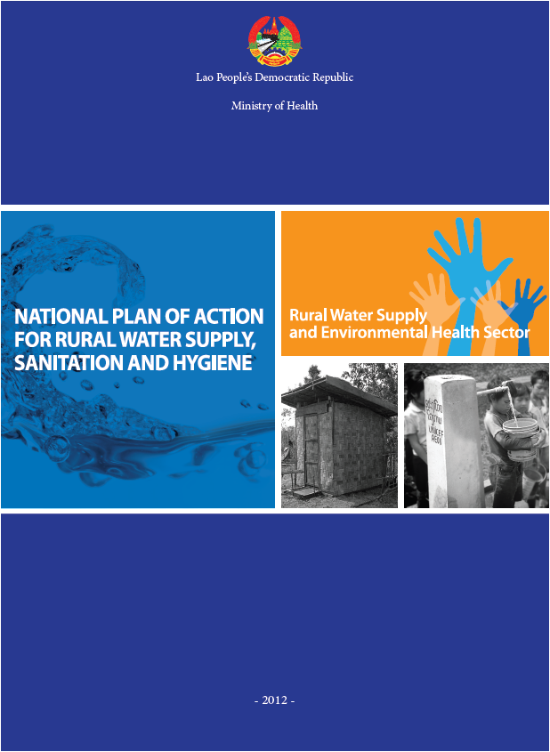

Annex 4. Operational Guidelines for NPA
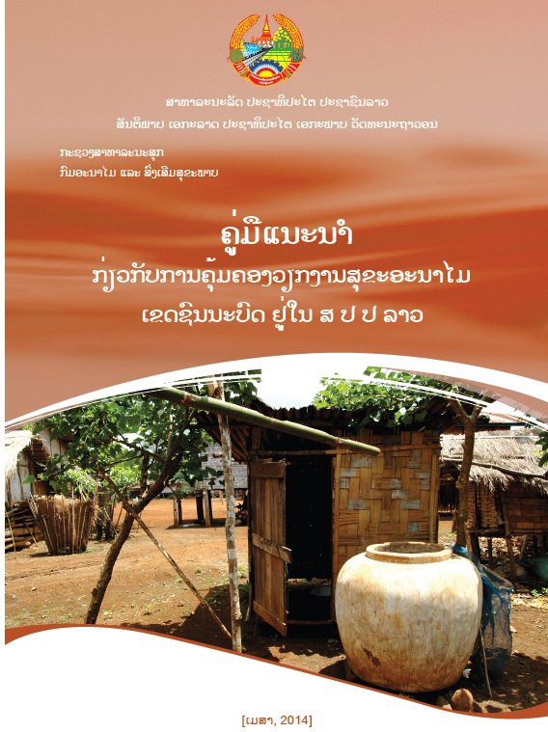

Objective
In order to have a reference and to ensure consistency in the implementation of rural sanitation activities throughout the country, this document is to be used for planning, implementation, monitoring and evaluation of the rural sanitation development programs, including the identification of responsibilities of the relevant state agencies at all levels.
Vision
“All Lao people, households, communities, health centers and schools across the country have increasing equitable access to improving levels of sanitation, water and hygiene services to meet their needs and contribute to improving the quality of their health, welfare and productivity and moving from Less Developed Country Status by 2020”
Principles
1. Equity
All Lao people living in remote areas are able to have access to improved water and sanitation services including the promotion of behavior change communication in sanitation in appropriate manners with equality in the access to services.

2. Sustainability of rural sanitation services and behaviors
… it is necessary to promote the service networks in providing latrine products so that local people can choose the options depending on the prices and the types of latrine. This is to ensure that local people can have access to quality latrines in different varieties.

3. Approaches differ for rural water, sanitation and hygiene
The approach is to create demands and to change behaviors of local population as the main principle in combination with service provisions of sanitation products supplied by the private sector.

4. Responsibilities shared between key stakeholder institutions and actors
… households must have ownership and responsibilities in the investments for latrine construction for their own household usage. However, in the process of the demand creation, the public sector, the local authorities and development partners have the important roles and duties in the implementation of this approach.

5. Learning and innovation in sector
… there is a need to conduct studies and to exchange lessons in the implementation of the pilot projects, the adaptation of approaches by learning from the success stories from the neighboring countries, for example, in the area of sanitation marketing and other issues

Key elements
Apart from the manuals, strategic guidelines, policies adopted for the implementation and expansion of rural sanitation, there are other documents, study reports which are references for the central and local levels for the identification of priorities and budgets to be utilized in the rural sanitation activities
1

Enabling Environment
Strengthening

Supply Chain
Development /
Strengthening
​

Demand Creation
1
2
3

It is a demand creation or a stimulation of local communities to change behaviors in the utilization of CLTS approach which is a process that includes problem analysis and creation of understanding in sanitation and health issues in the villages with active participation of the villagers. The ultimate goal of this process is to achieve an agreement to stop open defecation and to utilize improved latrines in the households.
2

In order to promote the local people at different levels to use improved latrines with the prices affordable for them, the promotion of latrines supplied by the private sector in rural areas is one of the important factors to increase the rate in accessibility and utilization of the improved latrines. Therefore, there is a need to establish the capacity of the private sector in the design and development of the latrine to be available in different types, in the development of market strategies, in the studies and pilot activities in providing credits to the private sector.
3

Implementation Cycle
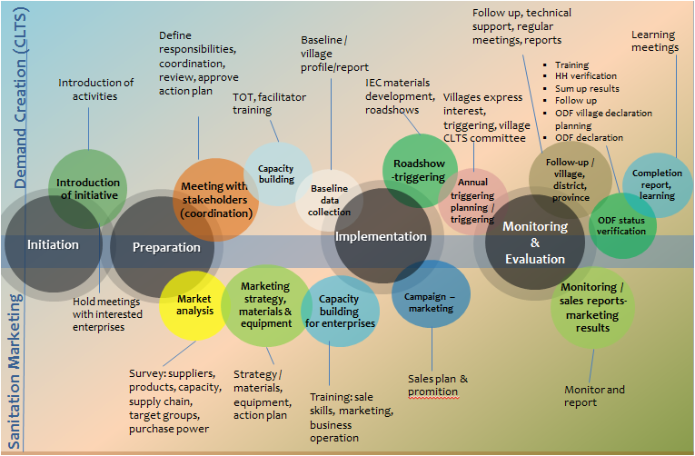

Role and responsibilities
Central level | 1. Department of Hygiene and Health Promotion (Ministry of Health)  2. Center for Environmental Health and Water Supply (Nam Saat)
Provincial/Prefecture level | 3. Prefecture / Provincial Administration Office  4. Prefecture Health Dept., Provincial Health Dept., & Provincial  Nam Saat
District level | 5. District Administration Office  6. District Health Office (District Nam Saat)
Village level | Village Authorities and volunteers

Financing Guideline
Based on the Nation Plan of Action on Rural Water Supply, Sanitation and Hygiene (2012-2015)
- ensuring sustainability
- Being able to implement at large scale
- Supporting local level’s ownership & building capacity in management

- Does not mean to subsidies hardware for households “ households sanitation is the responsibility of the household themselves – latrine construction and water waste management as well as environmental health matter”
- Government investment shall focus on public benefits: research (market strategy) , sanitation technology options, behavior change, communication tools and campaigns.
- Support mechanism to access financing e.g. revolving funds for poor households or guarantee supplier etc.

Monitoring and Evaluation
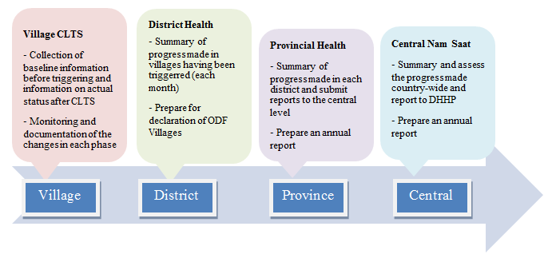

Annex 5. Sustainability Assessment of Open Defecation Free Villages in Lao PDR

Piloting CLTS in Southern Lao PDR:

Lessons and Prospects

Introduction
Over the last ten years, Community-led Total Sanitation (CLTS) has emerged as one of the most effective means of promoting sanitation in rural areas of less developed countries. Until recently, it had not been used in Lao PDR, but in the last three years the Lao government and a number of international development agencies have begun working with it, with some promising results.

Since late 2008 the World Bank’s Water and Sanitation Program has supported a small CLTS pilot project in the southern provinces of Champasak and Sekong, and in June 2010 all six participating villages were formally declared open-defecation free (ODF). The project was implemented by the provincial and district offices of Nam Saat, the Centre for Environmental Health and Water Supply in the Ministry of Health, with technical support from the World Bank. The pilot was a learning experience for all involved, and Nam Saat now plans to develop a much larger project in the same two provinces, building on the experience of the last two years.

This note provides an overview of the pilot, the lessons learned from it and some of the challenges that lie ahead in scaling up sanitation promotion to a larger number of villages and districts.

Applicability of CLTS
Progress in the targeted villages was not rapid, but the time taken was understandable given that this was a pilot; staff were using CLTS for the first time and needed guidance. Apart from this, the limited human and financial resources available in the districts constrained the amount of time that government staff could spend in the targeted communities.

Despite these challenges, the pilot delivered six ODF villages without offering any assistance towards the cost of sanitation hardware. Moreover it did this in communities that had received subsidies in the past, where there people may have had an expectation of financial support.

The impact of the pilot has not only been felt at community level. Having found a promotional model that really works, Nam Saat and other Health Department officials are now more interested in sanitation and confident that the new approach can be taken to scale.

Use of CLTS tools and techniques
With just two communities triggered during the training workshop and only six targeted by the project in total, staff had only a limited opportunity to test and refine their skills as CLTS facilitators. Similarly, when Kangyao core team extended sanitation promotion to other nearby villages under, they did so without using CLTS techniques. Experience from other countries shows that the quality of the interaction with the community is pivotal to the outcome of triggering processes, and undoubtedly further facilitator training and mentoring will be needed if the approach is to be scaled up in future. Whether it would have been appropriate to include the elements of shame and disgust in the triggering process remains an open question but it could be useful at least to explore this option in future projects given that it has proved effective in a wide variety of cultural settings worldwide.
While the project did not make extensive use of standard triggering tools and techniques, it retained a focus on ending open defecation rather than counting toilets; avoided the use of hardware subsidies; and emphasised collective, not individual, responsibility for improving sanitation. As such it was significantly different from earlier sanitation projects in the region and the new approach proved to be appropriate.

Post-triggering follow-up
The long delay between triggering and follow-up was a weakness of the project and happened primarily because this was a new venture for both Nam Saat and the World Bank. Not only were there constraints in terms of staff capacity and expertise; there was also administrative issues to resolve which also contributed to a loss of momentum in the period after the initial training. Once these issues were resolved, and World Bank had deployed a full-time adviser, the project was revitalised and by late 2009 it was clear that ODF status could be achieved in all of the participating villages.

The pilot also showed clearly that triggering is the start, not the end of the CLTS process and that frequent follow-up visits are vital, to build on the energy generated during the triggering process and help communities make concrete plans for ending open defecation. In future it would be important not only to include a program of follow-up visits in project workplans, but also to clarify what facilitators should do during these visits.

An interesting comment from one core team was that when Nam Sat started revisiting regularly, people realised that government was serious about improving sanitation and this alone was enough to generate a positive response. This is an important lesson for any effort to promote sanitation and hygiene, whether or not CLTS is used, and suggests that it would be possible to reach ODF status more quickly in future, provided there was efficient follow-up. Nam Saat staff also commented on the benefits of a closer relationship with the community, compared to the past when they visited only occasionally; by the end of the project, field staff and the core teams knew each other well.

One gap in community support that was not fully addressed was the need for technical advice on the construction of affordable, durable and desirable (preferably pour-flush) latrines; although a manual of options was provided after one year, this was adapted from one developed for Cambodia and was not customised to the project locations. Importantly, the project was unable to offer affordable designs for pour-flush latrines which were overwhelmingly preferred by the targeted communities. There is evidently a need for research into the development and marketing of more affordable options.

Government support
In Champasak Province, progress was enhanced by an increasingly supportive provincial government; the new Governor had made water supply and sanitation a development priority and expected the districts to deliver on this commitment. During Nam Saat revisits their motivational approach was not only to focus on the impact of open defecation but also to stress that government believed the time had come for the villages to develop and improve their infrastructure and services. The Governor’s mandate also helped to increase the support of district administrative heads, who showed increasing interest in the pilot. Broad-based support from government, together with growing confidence and enthusiasm for CLTS within Nam Saat, have created an enabling environment for progress and this bodes well for any future scaling up of sanitation promotion in the province. Having said this, Nam Saat receives minimal operational funding from government, which imposes severe constraints on field work at present and leaves them heavily dependent on donor support.

One risk arising from the Governor’s commitment is that an element of coercion could creep into the promotional process, but so long as village representatives lead the process, and the focus remains on behaviour change, not just building toilets, then government commitment should be a great asset. The different motivational forces at play (government commitment and community awareness of the effects of open defecation) need to be managed carefully, ensuring that they are mutually supportive.

One way of optimising government support and incentivising communities to become ODF could be to strengthen the link between sanitation promotion and the ‘Healthy Villages’ award scheme. There is considerable prestige attached to this award, which at present is given to only a small number of communities each year. It might be beneficial to increase the number of villages that can apply for the award, but even if this is does not happen, formal recognition of ODF status is a great encouragement to communities and should be continued.

Community leadership and decision making
It was fundamentally important that village leaders took ownership of the drive to become ODF as this added legitimacy to the promotional message, and the quality of village leadership proved pivotal to the outcome. In Kandone, it took considerable effort to reach ODF status but the headman was determined and made sure that the core team and other senior figures led by example, installing or renovating their own toilets first. Village leadership was noticeably weaker in Oudomsouk and, while ODF status was eventually achieved, the core team failed to expand the project to other villages in their cluster. The presence of at least four different ethnic groups in the cluster added to the challenge.

Community decision making in the project did not entirely follow the pattern envisaged in standard CLTS guidelines. A collective mobilisation process was followed, and a sense of collective responsibility for sanitation and hygiene developed in the targeted communities, but triggering did not lead to a rapid, collective decision to end open defecation. The process of change was more gradual, and typically began with the renovation of existing toilets followed by the construction of new ones by those who previously had nothing. The core teams persuaded many of these households one-by-one, not as a single group.

Another noticeable feature of the pilots was that only a minority of committee members were women; the process was very much male led, though members of Lao Women’s Union were active supporters and helped to set an example by being early adopters of hygienic latrines. There was no indication that gender bias had inhibited progress in the project, nevertheless there might be scope for a more central role for women in future CLTS projects; the options and potential benefits could be explored through attention to gender-related issues in project planning and implementation, not least because it is women who are primarily responsible for domestic hygiene and child care.

Sustainability factors
With ODF being declared just a few months before this review, it is too early to determine whether the pilot has achieved a lasting impact. Much will depend on whether those with simple dry pit latrines upgrade to more durable options, or at least replace them when they are no longer usable, and further technical assistance may be needed for this. The fact that most of the better off households needed little persuasion to install or renovate their pour-flush toilets suggests that there is already demand for high quality facilities, and if all households in a village could gain access to toilets that were hygienic and offered privacy, comfort and convenience, this would no doubt help to ensure that ODF status was sustained. The signs so far are positive in that village committees remain active and committed to ensuring that, in due, course everyone uses a latrine that meets minimum standards of durability and hygiene. A post-ODF workshop for the core teams in August 2010 helped to reinforce this commitment and ensure that the roles and responsibilities of community and government stakeholders were clearly defined and understood.

The increasing attention being paid to sanitation by provincial government, within and beyond Nam Saat, is also encouraging. If dialogue with the communities continues and technical support is made available to them, this should help to ensure that sanitation remains a local priority. The fact that Nam Saat has a permanent local presence should make it possible to provide this backup support indefinitely.

Incentives are relevant here, both to communities and to Nam Saat itself, since officers need to be motivated to continue providing technical and promotional support. Subject to the availability of funds, there might be scope for introducing rewards for communities that sustain their ODF status; possibly also for the field staff who support them.

Prospects for scaling up
The pilot has demonstrated that CLTS is applicable in the local context. There should, therefore, be scope for scaling up sanitation and hygiene promotion in the two provinces, subject to the availability of funding and capacity building support, both for the training and mentoring of CLTS facilitators and for the development and marketing of affordable latrine designs. As the scale of activity increases, it will also be important to develop a more formalised monitoring and reporting framework.

Apart from funding, human resources would perhaps be the main limiting factor on the scope for expansion, since most districts have just one or two staff available for field work. It may therefore be advisable for Nam Saat to develop operational partnerships with international development agencies based in, or near to, the two provinces, who could provide additional competent field staff. At the time of writing, this option is already being explored by the World Bank and Nam Saat.

Summary of lessons learned
- CLTS is applicable and it seems likely that, with Nam Saat becoming more confident in using the approach, and committed to scaling up, ODF could be achieved more quickly in the next batch of villages.

- The introduction of CLTS has been a motivator for Nam Saat staff in the two provinces, as it has provided a promotional model that can really deliver results.

- Triggering alone is not enough to secure community-wide, long term change in defecation habits. Substantial follow-up is needed to strengthen community motivation for change and (in some cases) to provide technical advice or logistical support with latrine construction (as was done in Kandone). Frequent follow-up visits convince communities that government is serious about improving sanitation, and it is important to avoid a long gap between triggering and follow-up, as this could cause a loss of motivation in community.

- Even with a new enthusiasm for sanitation and hygiene promotion, the limited number of district staff available in Nam Saat will present challenges in scaling up. Partnerships with competent NGOs could potentially be very useful if they could deploy additional field workers to support Nam Saat.

- Inadequate government funding for field work is an additional constraint on Nam Saat. If the Champasak Governor’s commitment to water and sanitation is to have a practical impact, it will be necessary to increase Nam Saat operational budgets.

- The introduction of CLTS, and the avoidance of hardware subsidies, have stimulated some amount of innovation in latrine design and construction, and most families have been able to build toilets without employing a mason. Having said this, there remains a strong preference for pour-flush latrines which are unaffordable to most poor households. Technical assistance in the design and marketing of more affordable, hygienic latrines would potentially be very useful and help to make scaling up possible.

- CLTS is good at delivering ODF communities but does not necessarily impact on other hygienic behaviour. There may be scope for including a hygiene promotion component in post-triggering follow-up, focussing as a minimum on the key issue of hand washing with soap or ash at critical times. Experience from other countries indicates that this too can be facilitated as a community-led process, so helping to generate a real commitment to change.

- Good quality training, followed by ongoing mentoring support, is essential for CLTS facilitators and should be incorporated into plans and budgets for scaling up.

- Community leaders can play a pivotal role in the achievement of ODF status. This role should be nurtured and encouraged, not only to accelerate progress in the leaders’ own villages but also for scaling up promotion to surrounding communities.

- Government commitment to sanitation and water supply is an important complement to CLTS as government decisions have legitimacy at community level. The challenge for the future is to make best use of both CLTS and government commitment, while keeping the focus strongly on ending open defecation rather than the number of toilets built.

- Formal recognition of ODF status is a matter of great pride and should be continued in future programs.

Annex 6. Advocacy Video ‘Out in the Open’

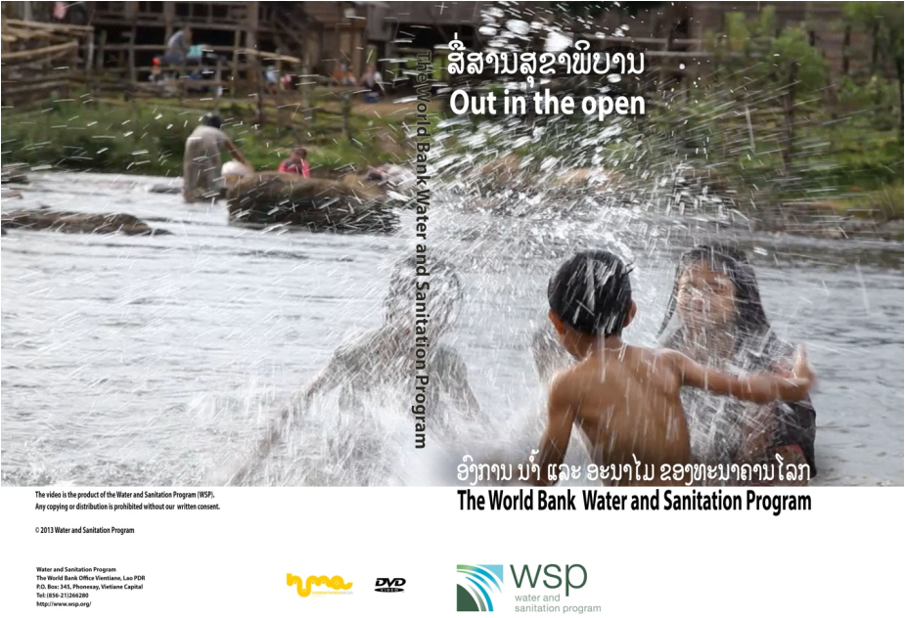

Annex7. Research Brief on Sanitation and Stunting

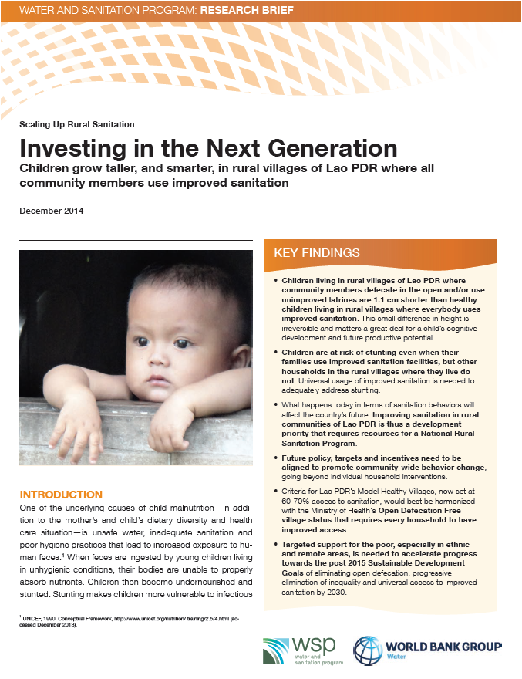

P132368 Sanitation Marketing in Lao PDR and P132452 Support to Sanitation Demand Creation in Lao PDR
P151311 Laos Impact Evaluation on Rural Sanitation
Two of these TA are expected to end by March 2016, while the impact evaluation has a longer time horizon till June 2017.
Documents referred to in the annexes are uploaded as supporting documentation in the operations portal.
At the time of processing these TAs, the Programmatic Approach (PA) was not yet ready and OPCS advised to use discrete TAs instead. Future support would be in the form of a PA for the sector.
CLTS is an approach used for demand generation for sanitation, which essentially - through external facilitation using levers as disgust, shame and other locally suited motivators - empowers the community to collectively stop open defecation and start to build and use toilets. Often, village regulations are used as a way to help support this change.
As part of the preparation of the new World Bank financed Health Governance and Nutrition project, discussions are conducted if and how the Model Healthy Village approach could be connected to multi-sectoral nutrition interventions.
The World Bank 2014. Implementation Completion and Results Report for a Community Nutrition Project.
World Bank 2014. Scaling Up Indonesia’s Rural Sanitation Mobile Monitoring System Nationally.
World Bank 2014. Investing in the Nest Generation: Children grow taller, and smarter, in rural villages of Lao PDR where all community members use improved sanitation
In case this MHV scheme will be supported under the new Health governance and nutrition project, nutrition related indicators may also be included in order to achieve MHV status (discussions ongoing).

